Logbook Week 11
March 31, 2026

On the eleventh week we:
- We made an initial design for the ribcage roller on the platform of the linear slide:
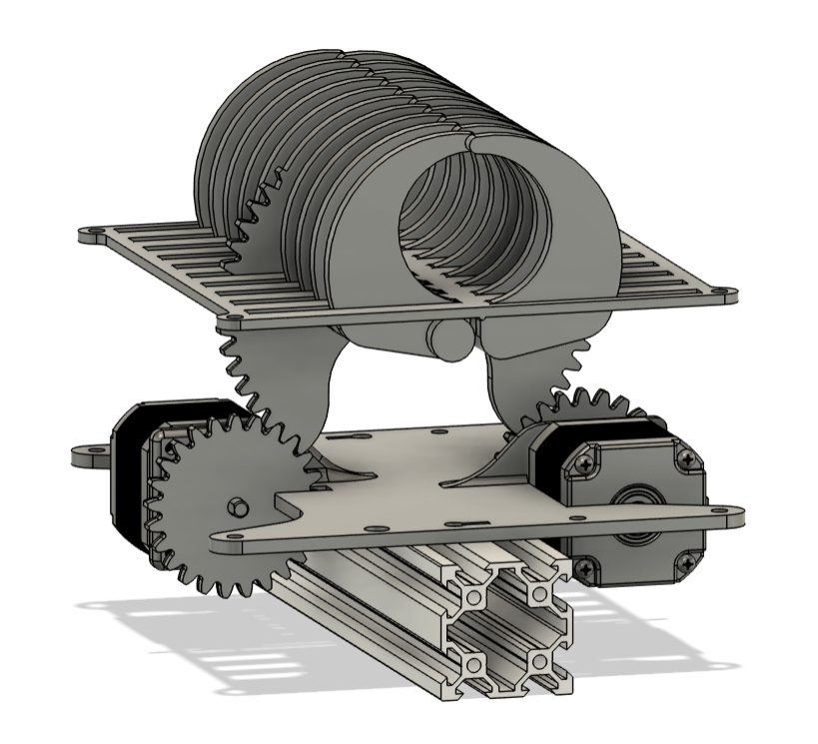
- We decided to put the motors directly on the platform to solve any issues we would have with flying wires as the platform moves. This initial design has extensions below the platform with teeth that are driven by the two motors. We decided on two motors instead of one so that we can control the order of when the ribs actuate so that we can get a better roll than if they both actuated at once. This design still needs spacers in between the bottom and elevated platforms, and it also still needs to be 3D printed and tested.
- We drilled holes in the linear slide rail so that it can be bolted down with M8 bolts to the table. We did originally plan to do two holes at the bottom at each end, but we learned that it wasn’t feasible to insert an Allen key at the side to tighten them, so we went with our other option to drilling a hole at the top too to give a slot for us to tighten the M8 bolts from the top once we get them through the bottom. We measured it wrong first and it wasn’t lining up with the holes on the table, but we just expanded one of the holes and tested it again and it worked. We tested bolting the rail down and it worked fine, we found compatible bolts and it held tightly, exactly what we wanted.

- Then, once we solved that issue and finished that task, we did another motor test for the belt drive as a final preparation for our capstone showcase:
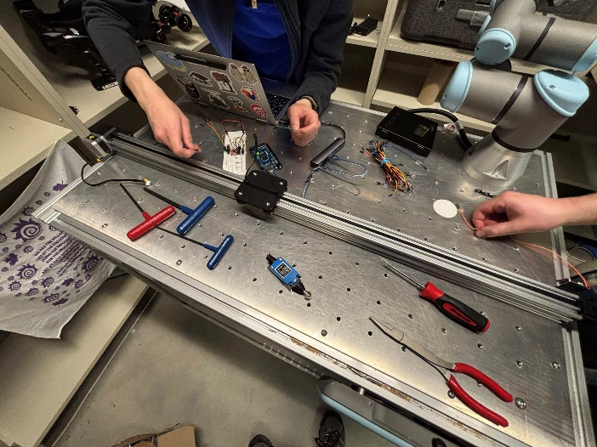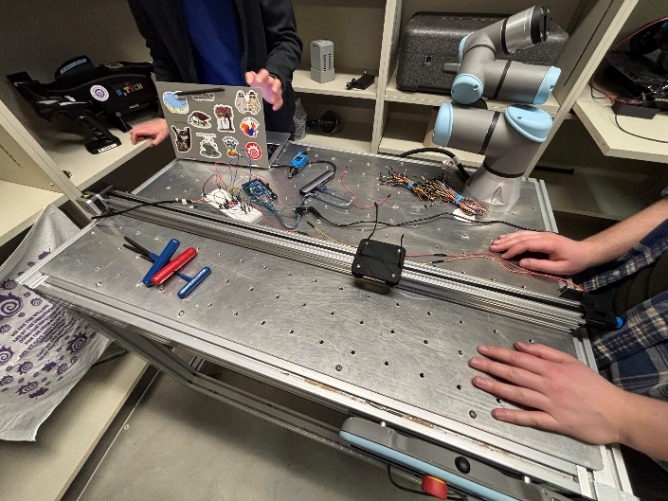
- After some issues with the limit switches not working correctly, it went pretty well. The motor drives the platform at a good speed for our line, and when the platform touches the limit switches it is able to go the other way. It’s a good foundation for our entire assembly line, and exactly as we planned.
- We quickly shopped for belt crimps for the belt. Two options: buy them from Amazon, or I found this place in Hamilton called 3D Printing Canada that sells a 10 pack for 3 bucks:
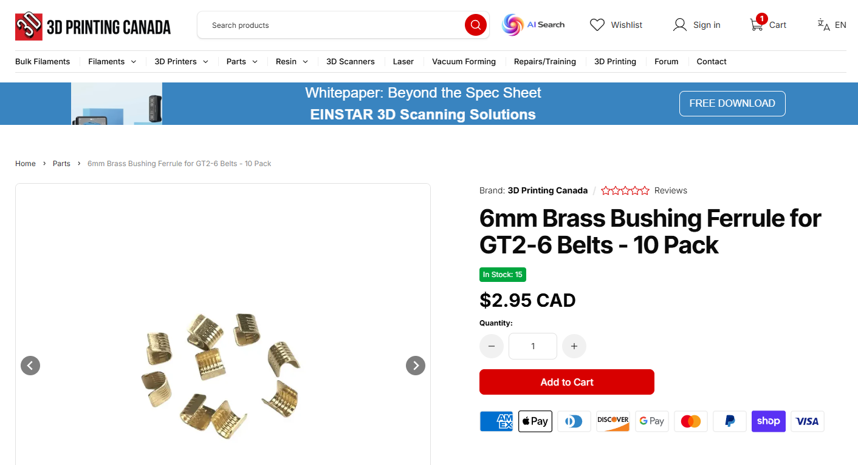
- We are going to do one of those options. To avoid shipping, one of us (perhaps me) may have to do a little trip to Hamilton to buy these and pick them up.
- We are also thinking of just getting wooden roller pins from Dollarama instead of the silicone ones, as hair and dust sticks really easily to the silicone ones, and perhaps they may not as much on wood. Rice may also slide off easier on wood. They are fairly cheap, 5 bucks each, so I am going to buy them and see if they will be better for our project. Plus, our silicone ones are birthday cake themed and it ruins the aesthetics of our assembly line.
- We found out the limit switches that Jacob bought (they came in today) won’t work. We assumed their wheel at the end meant that the switch could be activated bidirectionally from both sides, but in reality it still needs to be pushed from the front. It is hard to push them too, so we thought of options of just trying the sideways push with them anyway, and we tested it and it just won’t work, it’s too rigid. The motor torque was stopping before they would be pushed. So we will need to shop for an alternative bidirectional limit switch, or come up with a new solution entirely for telling the platform to stop at a substation.
- Jacob volunteered to work on the project poster. This is what he has so far, but he is still working on finishing it:
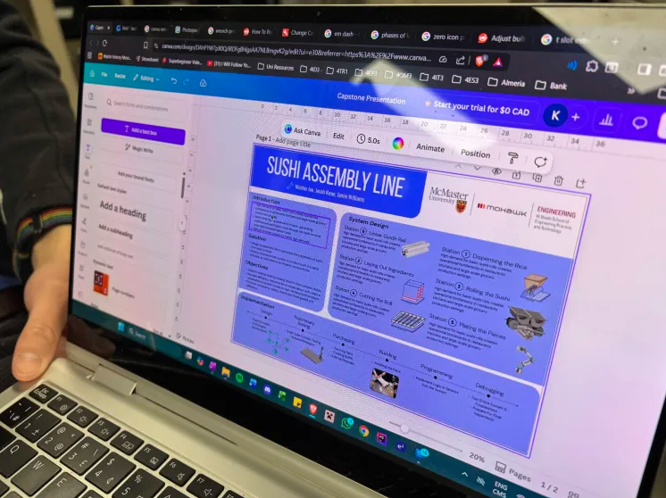

Things we will work on next week:
- We completed all the tasks I said we were going to do in my previous logbook entry! (Except for mounting the limit switches, as the ones we ordered aren’t going to work.) It’s the end of the semester so all that’s left is to finish our poster and bring it to the Automation capstone showcase
- We will continue to work on the project over the summer until Capstone II in our 4B Fall semester. We will start new tasks on designing and assembling new substations and finishing the wiring and programming plans. I want to get a label maker for labelling the wires and something we can use to draw a wiring schematic, perhaps. We can also start learning how to teach the robot.

